Home Made Meals
Simply The Best
Jordan B . Smith Jr | 7/10/18 | Volume 1

Introduction

L
ots of people get too busy or too stressed out on their job deadlines that they often miss the simplicities in life. From late night overtimes to waking up early in the morning only to remember that you have an early meeting with your boss. These dreadful moments can often mean skipping breakfasts and eating a late lunches or early dinners, which is why you should be reminded that it is definitely and necessary to take a pause, relax and go home at the right time to find a newly cooked dish ready to be served.

Special & Healthy

Home-made meals can be special if they are healthy. Life can be hectic sometimes, and a welcome mental relief comes when we decide to take a break from work and just go home to eat the latest recipe being developed. The kitchen can be a place of relaxation and pure stress relief. Your cooking should be combined with exercise like walking. Walking will help remove those extra pounds. Home cooked meals come straight from the oven, it has body benefits also that can reduce the fats and decrease the intake of sugar.

You should not depend your life on fast-food and restaurant meal deliveries that don’t care about you getting fat and overweight as long as they make money. I have observed that people who eat outside their homes tend to eat more than what their body can take, plus the bad things that can be possibly made from oversized meals. We love El Patron Mexican restaurant, but we always leave there stuffed after over eating. Mexican cuisine has not been one of my recipe choices but will be in the next Volume 2 as we tend to look at other healthy options.

Overeating is additionally one nice quandary of skipping home food. At home, you will eat the maximum amount as you would like without concern regarding your health most likely as a result of eating is healthier; there are a lot of veggies and fruits. You can’t purchase a banana or apple at McDonald’s unless it’s already a cooked pie or a crisp frozen dessert flavor. Joyce and I recently have added fresh watermelon as a dietary supplement. I encourage you to search out your favorite fruits and vegetables round the room.

Specially created For You

Home-made meals are essential as a result of it's expressly created for you. We tend to repeat visitations to a selected edifice or fast-food chain as a result of a belief that they serve delicious tasting meals. However, if we can contemplate the actual fact that these meals are served to thousands individuals a day simply because people are hungry for food.

It is undeniably distinctive to assume that the food you're to eat isn’t similar with k a lot of individuals. Home-made meals are specially created for you alone. You will have identical soup along with your neighbor at a selected time. However, it doesn’t have identical ingredients and style because the soup that you just have as a result of it’s your mum a particular agency au gratin it and not your neighbor’s mum. This is often only one of the various reasons why a home meal is essential. We have family traditional holiday meals that we just crave from someone special. Our kids will stop everything to come by our home when cooking specific favorites which we share in this first edition of home cooked meals.

Life will be robust every now and then. There comes an instant in your life after you can’t perceive your parents’ ill-natured or your siblings’ rants. You arrive home and grasp from your mum that she au gratin your favorite dish, that is your brother’s favorite furthermore and he or she tells you that he saved the last piece as a result of he is aware of you wish it.

It’s not only for the family, though. Varied times, once one or two argues and has a tough time to reconcile, one best move is to cook for the opposite. Home-made meals have these distinct attraction that once dead produce a lot of lasting impact of reconciliation and peace.

Food is one the foremost compelling things within the world, mostly as a result of we'd like it and that we have a desire for tasty and pleasant meals that we are able to boast to our co-workers within the morning. Another characteristic regarding home meal creations made meals is regarding the change of state sessions that you and your family members will remember.

Reference

What Makes Home-cooked Meals Special - Cuisine Bank. (n.d.). Retrieved from https://cuisinebank.com/what-makes-home-cooked-meals-special/

Why I Cook!
I
can’t wait to relax during the weekends and school vacations. After the morning or evening walk with my favorite food taster “Tommie,” I look forward to relaxing by deciding what to cook for dinner. This often begins with a search for something new and different so I can surprise Joyce once again. So this is the main reason why I cook.

At the top of an extended workday, one favorite ways to unwind is by slicing and dicing vegetables for dinner. The steady chop, chop, chop of my knife against the board quiets my mind and soothes my soul. Cookery is meditation with the promise of a good tasting meal after.

Passionate cooks have long recognized the therapeutic power of cooking time. Preparing a healthy salad is not like the rest of the tasks on a daily basis as a result of it's a nutritious personal event that focuses upon obtaining me to calm down.

Culinary, medical aid is being employed as a part of treatments for a good vary of mental and activity conditions. However, I take advantage of it to quiet my mind and soothe my soul. Three years past a recent graduate from our highschool struggled with mathematics and thru serving to her overcome her fears regarding arithmetic we have a tendency to conjointly discovered other ways to resolve issues regarding spacial thinking and perimeter problem solving through the establishment of important connections to the student’s favorite meals. Even these days I still anchor learning to one thing inside a student’s life. Tamika anchors her learning about area and perimeter to her favorite meal; her dad’s shrimp scampi on noodles.

Now cookery medical aid is that the treatment du jour at a growing variety of mental state clinics and therapists' offices. It’s being employed as a part of the procedure for a good vary of psychological and activity health conditions, together with depression, anxiety, uptake disorders, ADHD, and addiction. I take this research to a different level that helps provide relief of math anxiety issues with failing students. This instructional therapy has worked for nearly 10 years.

Recipe for a Healthy Mind

One visible link between cookery and mental state is nutrition. It’s easier to regulate the standard of your diet once you prepare the food yourself. And there’s growing recognition that selecting a high-quality diet plays a significant role to keep your brain healthy.

The title of a recent editorial within the Lancet psychological medicine says it all: “Nutritional medication as thought in psychological medicine.” It’s an idea that sounds a lot of revolutionary than it in all probability ought to. Reflections and past experience of cooking in the kitchen reminds people of the link between brain health and several other nutrients, together with polyunsaturated fatty acid fats, B vitamins, iron, zinc, metal and amino acids. to create positive that your brain is obtaining enough of those vital nutrients, it helps to grasp precisely what you’re feeding it
.
A Dash of Attentiveness

Also, the exercise of cookery will nourish your psychological well-being. Wedding and family expert Lisa Bahar encourages her purchasers to follow attentiveness within the room. My kitchen is arranged for cooking. We spend quality time in the kitchen, and most of our gifts to each other are cooking utensils. For instance, peeling and sectioning a tangerine for a fruit salad focuses our perception upon its skin, the color, the touch, and the smell. When you peel and section the fruit, notice the moment-to-moment sensations, cherish the spray of juice once you break through the peel. Finally, pop one in all the in the buff tangerine sections into your mouth, and savor the succulence and flavor.

When you’re specializing in the instant this manner, you’re not ruminating over past slights or worrying regarding future issues. Attentiveness conjointly helps cut back stress and promotes bigger relish always.

A Splash of Appreciation

Once you’ve finished prepping your food, take an instant to mirror on however it reached your table. Within the example of the tangerine, Bahar notes, a seed was planted, a tree grew, the tree blossomed, and eventually, a tangerine appeared. “ Then the tangerine was picked, place in a very box, transported to a distributor, place in a very bag and transported once more to a grocery,” Bahar says. plenty went into delivery of the tangerine to you, and appreciating one tiny orange marvel might assist you feel higher regarding life overall.

A Sprinkling of creativeness

For many folks, cookery is the process of thinking about the flavors you gravitate toward and take a look at assimilation in numerous dishes. Also, instead of dashing resolute get an extended list of ingredients, be galvanized by what you have got there. It’ll prevent time and stress, each of that tend to be barriers to creativeness, and guess what? You’ll have developed your own new direction or recipe.” The sense of accomplishment you are feeling after will be a lift for your vanity.

A Heaping containerful of Joy

It’s straightforward to dismiss cookery as merely another house task. However, you will derive a joy from cookery that you just don’t get from, say, folding laundry or dusting shelves. The reason: uptake is that cooking is an innately satisfying expertise. So cooking, that ends up in absorption, contains a sturdy, intrinsic reward system. To stay fun at the forefront, offer yourself permission to play along with your food. Kanner says, “People get therefore decorated au courant doing a direction rather like in a garden or creating it rather than watching on the cookery Channel. Develop your own fancy methods, and don’t worry regarding perfection.

Mix Well for association

Cooking with a partner will spur communication and cooperation. “Getting a meal on the table suggests that golf stroke aside variations and grudges and specializing in the task at hand,” says Kanner. If you don’t have a similar food likes and dislikes, it’s conjointly an opportunity to hone your conflict resolution skills. The need to eat sooner instead of later may be a powerful incentive to compromise.

Reference

Kitchen Therapy: Cooking Up Mental Well-being. (n.d.). Retrieved from https://www.psychologytoday.com/us/blog/minding-the-body/201505/kitchen-therapy-

Traditional Family Evening Meals

Jordan’s Cheese Steak Casserole
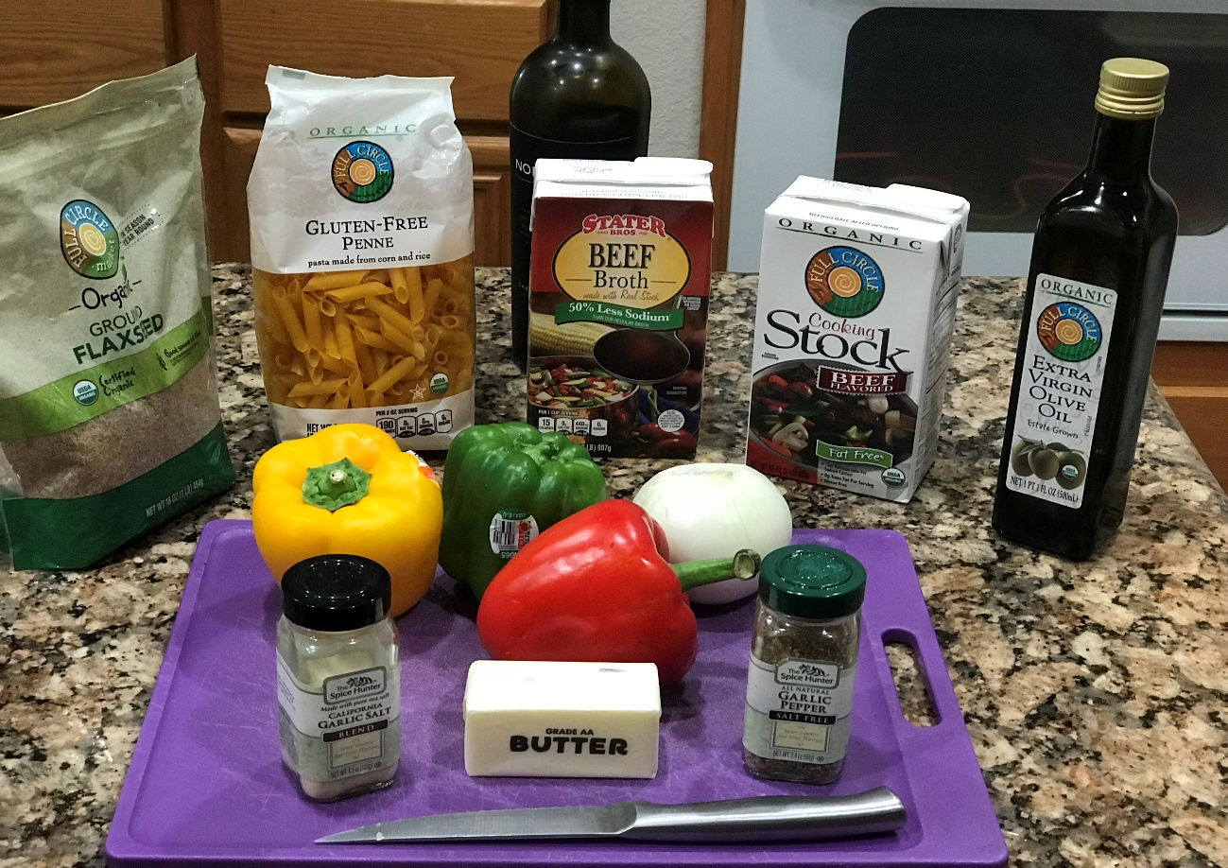

Jordan’s Cheese Steak Casserole – July 2018

Description: I often never follow a recipe when I find it on the internet or in a cookbook. I remember having paid way too much for a Philliy Cheese steak at an Army-Navy football game, but I loved the taste of the hot melted cheese, onions, etc. while I was freezing my tail off in Philadelphia in December 1972. Over the years I have had several even the ones from Subway. Now I make these at home, but then I forgot to get the buns. So this recipe is how to improvise and still have the same great flavors. This Cheese Steak Casserole is a delicious anytime meal that your family will love!

Prep Time 20 minutes
Cook Time 20 minutes
Total Time 40 minutes
Servings 6 people

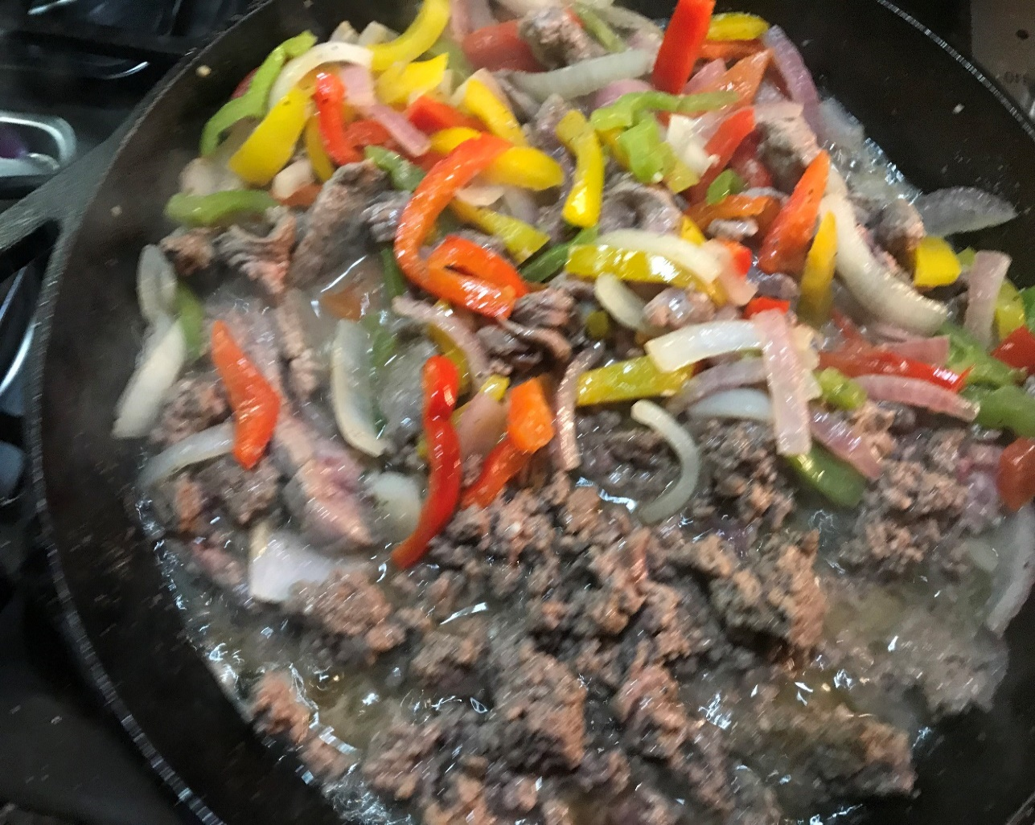

Ingredients

14 Ounces penne shells
32 ounces beef stock + 32 ounces of beef broth
½ Stick 4 TBSPs butter
2 garlic cloves or 1 tsp minced garlic
¾ lbs. or 1 Rib Eye Steak (approx. .85 lbs.)
½ lbs. or 1 piece of Flank Steak (.45 lbs.)
8 ounces cream cheese
1 green pepper
1 red pepper
1 yellow pepper
1 red onion
1 cup portabella mushrooms
1 tsp minced garlic
1/2 cup reserved cooking liquid from noodles
1 cup shredded mozzarella
6 slices provolone
Salt & Pepper to taste

Directions

1. Heat up your kitchen appliance (oven) to 350 degrees.

2. Mix the beouf (beef) stock and broth to cook the shells per package directions. Set aside for later and keep 1/2 cup of the stock before exhausting the noodles.

3. Soften the butter, cook the garlic for thirty seconds, then add the bell peppers and onion and cook till tender, for about three minutes. Add the mushrooms and simmer for two additional minutes.

4. Add beef, season with salt and pepper, and cook till deep-fried through. Stir within the cream cheese till liquid.

5. Stir within the reserved preparation liquid from the noodles, the noodles, and also the cut cheese. If your cooking pan is oven-proof, prime with sliced provolone.

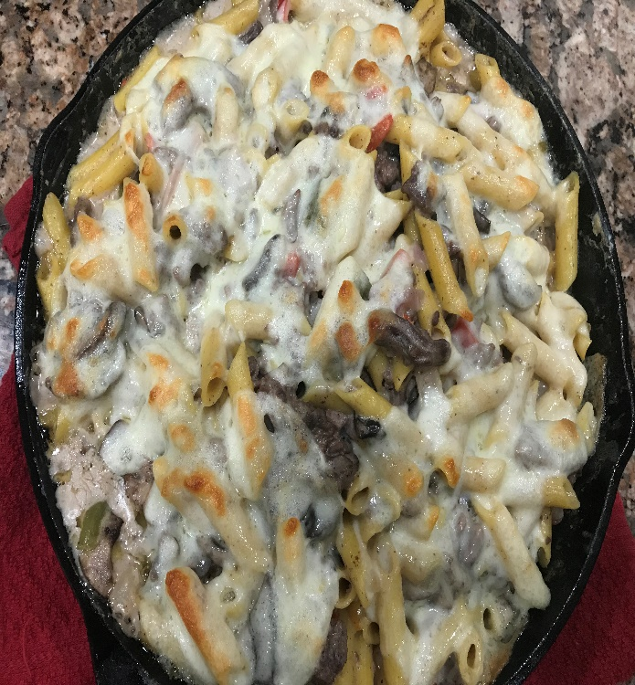

July 6, 2018

Smothered Baked Chicken Recipe
Description: This smothered chicken and rice meal is baked to perfection, and the meat falls off the bones.

Prep Time 20 minutes
Cook Time 20 minutes
Total Time 40 minutes
Servings 6 people
Ingredients

5 Small Red Potatoes
2-Stalk of Celery
4 Tbs Butter (Optional)
4 Tbsp All-Purpose Flour
3 Cups Chicken Broth
1 Chicken Flavor Bouillon Cube
Seasoning
1 Tbs Parsley Flakes
2 Tsp Seasoning Salt or Salt
1 Tsp Garlic Powder
1 Tsp Thyme

Directions
1. Ok, therefore what we're progressing to do first is fill a giant bowl up with cool water. Add one tbs of salt to the bowl to make a brine solution and add your frozen chicken to the salt water. Enable the chicken to take a seat within the salt water till it unthaws. If your chicken is not frozen, add it to the salt water answer anyway and scrub it with the salt water answer.

2. Whereas your chicken is sitting within the brine, you are going to cut your onions and peppers into tiny items and chop every tiny potatoes into items of four (quarters).

3. Create the gravy mixture suspension. You are going to mix your broth and flour. Therefore add your flour to the broth and stir it in well till it dissolves and use large tablespoons of flour. The suspension can thicken and switch into a gravy because it cooks.

4. Heat your kitchen appliance to 350 degrees. Confirm that the kitchen appliance preheats for a minimum of ten minutes before adding the chicken to the kitchen appliance, and it will take ten minutes to complete following few steps.

5. Ok, therefore, let's target the chicken currently. Once it unthaws, take away the surplus fat and discontinue any supporting excess skin which will get on the chicken. Take away additional yellow fat pockets and also the thin membrane below the skin. Keep simply enough skin to hide the meat and cut the remainder and discard

6. Afterward, seasoning your chicken thighs with the seasonings and massage the seasonings in very well.

7. Get your baking dish or use a giant forged iron and place one chicken flavor cube, seasoning and also the shredded vegetables into a baking pan or dish.

8. Add your seasoned chicken, followed by the gravy suspension.

9. Lastly, add one tbs of butter. Butter is nonmandatory therefore if you would like to travel the healthier route be happy to go deficient and leave it out. Butter can help the chicken brown and adds a touch of flavor to the gravy.

10. Place the chicken within the kitchen appliance and bake it for two hours.

11. After an hour, stir the gravy in to smooth it as it thickens. The flour encompasses a tendencies to ooze all the way down to the bottom of the baking pan, therefore make sure you stir entirely, confirm you stir the gravy in well before your sauce thickens. These square measure best served with egg noodles, rice cauliflower, and polished white rice, and they are finger licking smart. Serve together with your favorite vegetables or beans. Enjoy!

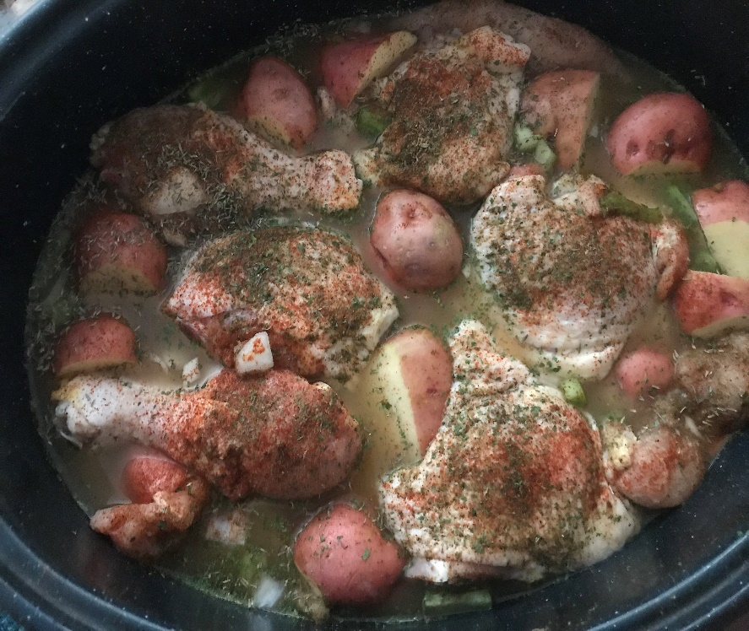

The Best Ground Beef Tacos

Description: I never made tacos from scratch. I would always use McCormick or some other package for making tacos. I search more than twenty-five recipes and then developed my own. This is the only way to make tacos. You will love this recipe.

Prep Time 10 minutes
Cook Time10 minutes
Total Time 20 minutes
Servings 6 people

Ingredients:

1 pound boeuf or ground turkey
1/2 to 3/4 cup shredded white or yellow onion
1 to three garlic cloves, finely minced, or one teaspoon garlic powder
1 tablespoon seasoner1 pound boeuf or ground turkey
1/2 to 3/4 cup shredded white or yellow onion
1 to three garlic cloves, finely minced, or one teaspoon garlic powder
1 tablespoon chili powder
2 teaspoons ground cumin
2 teaspoons ground coriander
1/2 teaspoon salt
1/4 to 1/2 teaspoon black pepper
8-ounce will pasta sauce
1 jalapeño, seeded and finely minced (optional)
Taco shells
Taco toppings of alternative (avocado, onions, lettuce, hot sauce, red or inexperienced condiment for a good surprise strive HERDEZ® dip condiment

Directions:
1. In a huge cast iron skillet over medium heat, add the meat, onion, and a pinch of salt and pepper. Cook, usually stirring and breaking the meat into tiny items till the beef is browned hard-baked through, 5-7 minutes. Drain any excess grease, if needed.
2. Next, reduce the heat to medium and stir in the garlic, beef flavoring, cumin, coriander, salt, and pepper. Cook for a concerning thirty seconds till the mixture smells flavorable and deliciously perfumed.
3. Finally add the pasta sauce and minced jalapeños, if using. Simmer the mixture for 5-10 minutes, stirring sometimes. Season to style with further salt and pepper, if needed.
4. Serve in your favorite taco shells along with your alternative of toppings (makes nice taco salad dish, too!)

.

Jordan’s Cajun Collard Green with Smoked Meat & Sausage Recipe
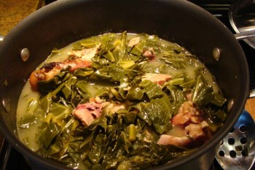

Description: Collard greens are an excellent source of vitamin K, vitamin A (in the form of carotenoids), manganese, vitamin C, dietary fiber, and calcium. They are also a good source of vitamin E, copper, protein, magnesium, phosphorus, vitamin B5, folate, omega-3 fatty acids, niacin, vitamin B1, and potassium. You will love this recipe. Why you should eat your collard greens

Reference
Dsc07031 | Vintage Green Greens Are An Excellent ... - Flickr. (n.d.). Retrieved from https://www.flickr.com/photos/117560929@N03/33670979305/

Prep Time 10 minutes
Cook Time10 minutes
Total Time 20 minutes
Servings 10-20 people (I make and freeze left-overs for later meals)

Ingredients
2-3 Lbs. of Smoked Turkey Legs, tails or bottoms
2-3 Bunches Collard Greens
4 Links Andouille Sausage
1 large Mayan Onion, chopped (1/2 for meat ½ for cooking greens)
1/2 Green Bell Pepper, chopped
1 Red Bell Pepper, chopped
2 Tbs minced garlic
4 Strips of bacon cut into 1-inch pieces
4 Collard Green Stems, chopped
1/2 Cup Margarine or Butter
3 Tbs vegetable oil
3 Quarts of Water
2 Quarts of Chicken Broth (2- 32 Ounces Chicken Broth)
2 Cups of turkey broth from meat
3 Tbs Apple Cider Vinegar
2 Chicken Flavor Bouillon Cubes
2 Tbs Sugar
1 Tbs seasoning salt
2 Tbs Crushed Red Pepper
1 Tbs of Louisiana Hot sauce

Season to taste with hot sauce, vinegar, salt, and pepper.
Directions
1. Rinse hocks or tails with water.

2. Place a pot over medium heat. Add meat, water to cover, ½ onion, 3 cloves of garlic then cover with a lid leaving a crack on the sides. Cook for 3 hrs. (Fast method Use a pressure cooker add ½ onion & 3 cloves of garlic set cook time for 28-30 minutes)

3. Add 1 tbs kosher salt, 4 tbs apple cider vinegar, and water to a big bowl.

4. Remove but keep 3 stems from collard greens. Chop collard greens, then place in bowl of salt water-vinegar solution. Save stems and cut into ½ inch pieces or smaller. Let rest and mix for an hour. Rinse thoroughly.

5. Chop your peppers, onions, garlic, bacon slices, and collard stems into small pieces.

6. Once meat is done cooking, drain water then rinse well.

7. Chop meat into small pieces.

8. Rinse collard greens and drain dirty water.

9. Place large pot over high heat.

10. Add oil to pan.

11. Add peppers, onions, garlic, bacon slice and sear for 3-5 minutes

12. Add stems pieces and meat continue frying until golden brown (5 minutes). Add collard greens, then stir until collard greens wilt. Stir for about 4-5 minutes.

13. Reduce heat to medium heat.

14. Add meat.
15. Add margarine or butter, broth, and vinegar.
16. Add bouillon cubes and seasoning, then stir in well.
17. Cover with a lid leaving a crack on the sides.
18. Cook for about 1 to 1.5 hours.

19. While cooking place andouille sausage in a cast iron skillet with 1 cup of water and on medium-high heat. Rotate frequently turning every 2-3 minutes. After water evaporates brown the sausage on all sides and set aside until the collard greens are cooked.

20. Serve the sausage with the collard greens and enjoy Cajun style! If you are daring, then you may also add in a few boiled Crawfish as well.

Jordan’s Southern Style Fried Pork Chops
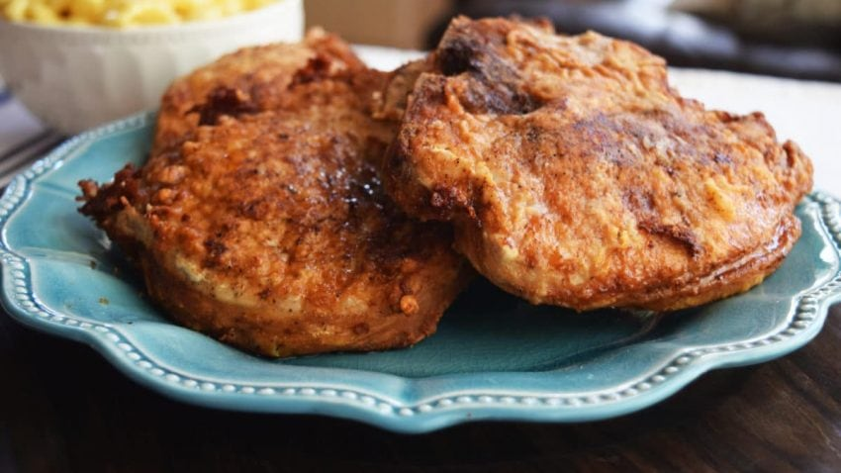

Description: Pork Chops were not served very often at our house when I was growing up. My first experience with pork chops was while attending the United States Naval Academy from 1972-1976. Southern Fried Pork Chops is now an essential meal at our house. Most of my best cooking has taken place after the kids are grown and moved away. I do remember my mom standing at the stove cooking and us (me and my brother) sitting at the kitchen table waiting very impatiently. One thing is for sure this is really a simple dish. It is a southern dish because of roots is tasty wanting the guests asking for more and more!

Prep Time 1 Hour 10 minutes
Cook Time10 minutes
Total Time 1 Hour 20 minutes
Servings 4 people

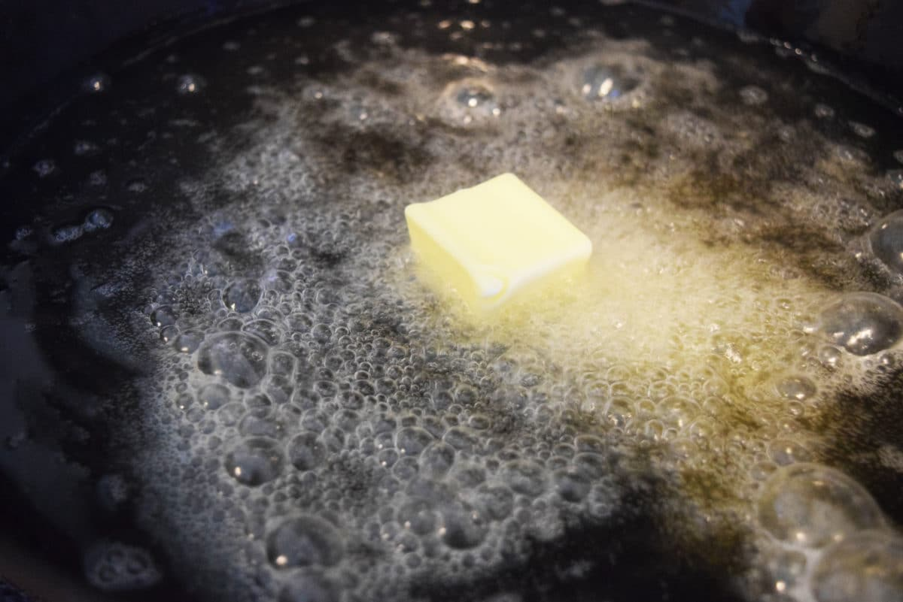
To get golden brown pork chops place 2 tbsp of butter in the hot oil before frying

Ingredients

4-Bone in Pork chops or thin cuts
4 Tbsp of Dry Pork Rub (I use Stubbs or use your favorite pork marinade)
4 Tbsp Butter
Flour Mixture
1 cup flour
1 tsp seasoned salt
1 tsp black pepper
1 tsp onion powder
1 tsp garlic powder
Egg Mixture
1 cup buttermilk
1 large egg
1 tsp crystal hot sauce or 1 tsp ground red pepper
Italian Bread Mixture
1 cup Italian Panko breadcrumbs
1tsp paprika
1tbsp parsley
1tsp sea salt
3 non-stick pie pans for mixing and dragging
Cooking Oil – use enough oil to cover ¾ the height of the chops

Directions

- Clean and wash the pork chops

- Apply Stubbs Dry Pork Rub to marinade for 1 hour

- Season pork chops by dragging in flour mixture, then egg mixture, then panko mix and back into flour mixture

- Cook the chops in ¼ inch oil (4-5 minutes on each side)

- Drain on paper towels – Enjoy!

Note: Use leftover chops with eggs for a great twist on breakfast.

Cajun & Creole Dinner Meals

Crawfish & Shrimp Boil
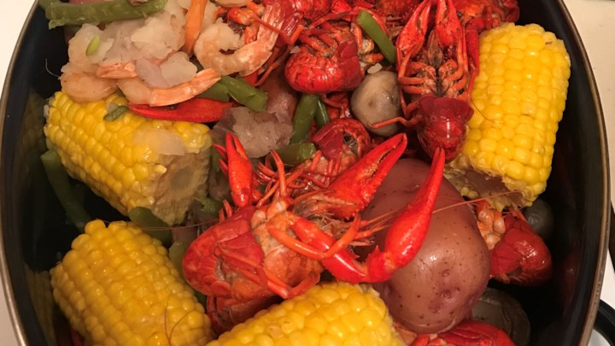

Description: What a feast! Invite the family and dig into this messy, yummy boil. Combining crawfish, shrimp, crab, andouille sausage, smoked sausage, potatoes, and green beans, this is a dish you'll crave over and over. I know because I have been eating crawfish and Cajun cuisine meals since 1984. I remember when returning from Okinawa and arriving at New Orleans Naval Station when the caters asked me if I sucked heads? I retorted “Hell No!” They laughed and said out loud, “You will before you leave!” They were right, and the rest is history. After leaving New Orleans, I searched for the right recipe. You can add any other seafood or vegetables to your liking."

Prep Time 20 minutes
Cook Time 1 Hour 15 Minutes
Total Time 1 Hour 35 minutes
Servings 2 – Cajun Lovers or 5 Cajun Rookies

Ingredients
Spice Mix
4 Cloves of Garlic
2 (3 ounce) packages dry crab boil (Slap Your Mama or Zatarins or Louisiana Crawfish boil)
4 Tbs Kosher Salt-
1 Tbsp Liquid Shrimp and crab boil
2 tbs. dry mustard
2 tbs Ground Allspice
2 tbs Chili Powder
2 tbs Cayenne Pepper
2 tbs Italian Seasoning
2 tbs Granulated Garlic
2 tbs Smoked Paprika
4 Tbsp Apple Cider Vinegar
4 whole bay leaves
8 Quarts of Water
2 Quarts of Beef Stock
The Stuff
4-6 corn cobs, cut into thirds
1 bag little red potatoes, whole
1 lb. hot sausage links (hot Italian, andouille, hot links) chopped in 2-inch pieces
1 Package Frozen Green Beans
1 bottle dark beer
5 lbs. of crawfish
20 pieces of Jumbo Shrimp
2-5 Snow Crabs

Directions:

Place 8 Quarts of cold water in a large pot. Add spice mix and bring to a boil.

Add potatoes, corn, and sausage and bring to a second boil.

Add crawfish and crabs and bring to a third boil

Add shrimp and bring to a final boil and then let simmer for 10 minutes.

DO NOT EAT UNTIL AFTER RESTING FOR AT LEAST 30 MINUTES!

Turkey Necks, French Style Green Beans, Potatoes
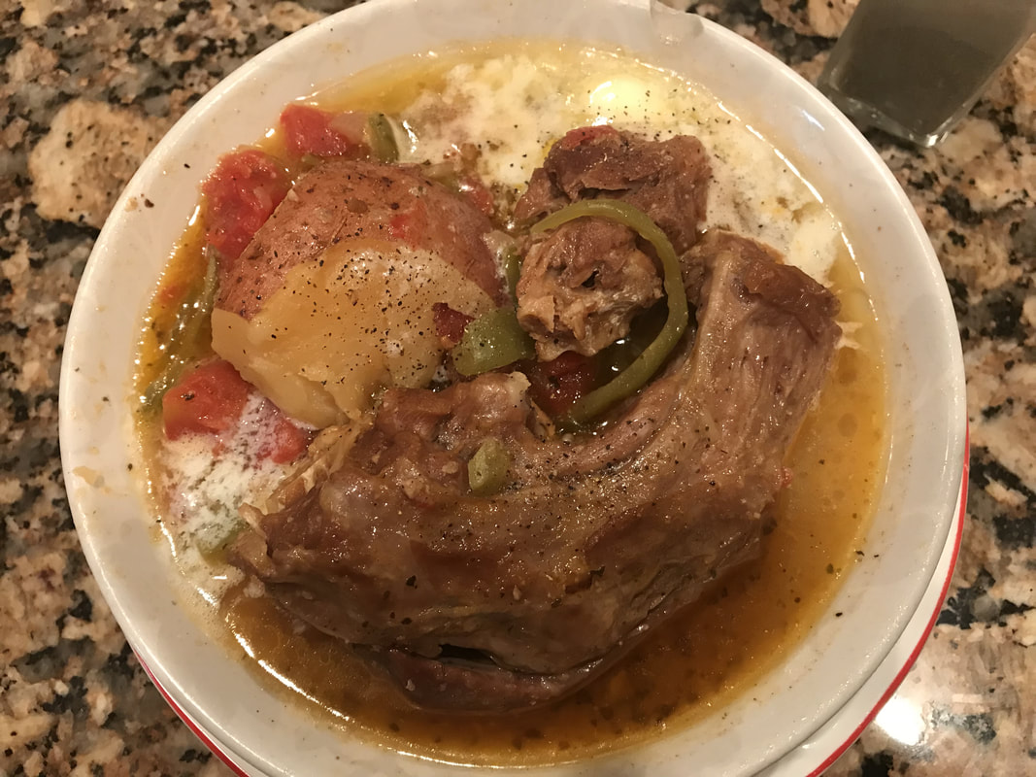

Description: Great for watching football games and full of rich creole flavors. The recipe from Annapolis Creed: Enduring Classic Recipes fills the home with wonderful flavors during the most wonderful times of the cool fresh airs during the fall and winter of each year. This is an excellent meal to keep the mind fit and the body feeling so good on the inside. The blend of tomatoes and other vegetable additions helps create a vibrant and tasteful juice to the delicate and tender turkey necks. This recipe works well even with leftover turkey scraps like the bottom of a turkey, legs, and necks. This saves money by extending the use of what is typically thrown away.

Prep Time 20 minutes
Cook Time 3 Hour 15 Minutes
Total Time 3 Hour 55 minutes
Servings 6

Ingredients

5-6 Turkey Neck Bones packaged from Butcher
3 large red potatoes or 9 mini red potatoes
1 can green beans (I like French style)
1 can Hunt Diced Basil & Garlic tomatoes
2 tablespoons of vegetable oil
4 pieces of bacon strips
2 tablespoons of minced garlic

Broth Seasoning during the simmer

24 ounces of chicken broth
2 chicken bouillon cubes
¼ cup apple cider vinegar
¼ cup sugar
8 tablespoons of butter
3 tablespoon seasoning salt
1 tablespoon onion powder
2 ½ tablespoon garlic powder
1 tsp black pepper
1 tsp cayenne pepper

First Cooking Time (1.5 - 2 hours)

Rinse your turkey necks and cover with water up to the handle screws. Boil your turkey necks in a big pot of water over medium heat (Number 7 on a gas stovetop) with ¼ onion, 1 tbsp garlic pepper, 1 tbsp garlic salt, 1 tbsp salt, 1 bell pepper until tender. Cook without the top then cover with a top when tender

Prep Potatoes

Meanwhile, chop up 3 red potatoes into small pieces or mini (halves) and soak them in a bowl of water

Slice up one big onion into small pieces and slice up 4 strips of bacon into small pieces

Get a frying pan and place it over medium heat. Add 3 tbs. of oil to the frying pan. Add your chopped onions and bacon pieces along with 2 big tbs. Of minced garlic. Allow them to fry for 10 minutes or until veggies become light brown. Turn off the fire once done and set it aside.

Once your turkey necks are done drain most of the juice.

Final Preparations

Add to the pot, diced tomatoes, your chopped up potatoes, and your fried minced garlic onions and bacon pieces.

Add 6 cups of chicken broth and return to a boil

Season: Add to the pot 2 chicken bouillon cubes,1/4 cup of apple cider vinegar, 1/4 cup of sugar, 3 tbs of season salt, 1 tbs of onion powder, 2 tbs of garlic powder, 1 tsp of black pepper, and 1 tsp of cayenne pepper

Simmer over medium heat for 1.5 hour or until your green beans are as tender as you desire.

During the last 30 minutes turn down to simmer (3) and uncover to reduce the liquid, add the green beans and diced tomatoes. Turn off and let rest for 10 minutes before serving.

Enjoy this recipe

Gumbo from scratch

Description: Gumbo is a stew or thick soup, usually made with chicken or seafood, greens, and okra or sometimes file` as a thickener. It is the only time I have Okra throughout the year. But what I really like about gumbo is that it is the most effective use of leftovers for several meals. For instance, I collect the meats and fish from leftover chicken thighs. I buy the family pack that generally has about eight pieces that is too much for the two of us, so I take half and place in a storage bag and place in the freezer. When I prepare to buy the jumbo shrimp in the bag, I keep in mind that part is for the shrimp scampi and 1/3 of it is saved for the gumbo. When I make red beans and rice half of the andouille sausage is set aside.

Prepare the Chicken

6 boneless chicken thighs (about 1 1/4 pounds), skinned
1 1/2 tablespoons Cajun seasoning
A pinch of Tarragon (2 shakes)
A pinch of Celery salt (2 shakes)
A pinch of Garlic salt (2 shakes)
A pinch of Spike (2 shakes)

Prepare the Roux

Cook 4 pieces of bacon, set aside the bacon and save the grease to add flavor to the roux.
½ cup canola oil
½ cup all-purpose flour
1 1/2 cups chopped onion
1 cup chopped green bell pepper
2 celery stalks, chopped
4 ounces andouille sausage, thinly sliced
1/2 teaspoon kosher salt

Prepare the Soup

8 cups lower-sodium beef broth
4 cups vegetable broth
1 cup water + 1 bouillon cube (as needed)
2 garlic cloves, minced ( fresh or 1 tbsp minced)
2 bay leaves
1/2 teaspoon dried thyme leaves
1 (14.5 ounce) can stewed tomatoes
1 (6 ounce) can tomato sauce
2 teaspoons gumbo file powder
Salt and Pepper to taste

Add Seafood

1 pound lump crabmeat (Imitation crab works just as good)
1 pounds uncooked medium shrimp, peeled and deveined
2 lbs of seafood mix from Butcher (Optional as pictured above)
1 tablespoon white sugar
2 tablespoon gumbo file
1 tablespoon Worcestershire sauce

Prepare the Okra

1 10 oz frozen okra
2 tablespoon vinegar
1 tablespoon Worcestershire sauce
Salt and pepper lightly

Serve the Gumbo

2 cups cooked white rice (amount of rice may vary or rice Cauliflower)
1/4 cup chopped green onions
Hot pepper sauce (optional)

Directions

Step 1

Preheat oven to 400°
.
Step 2

Sprinkle and rub four (4) chicken thighs with Toni’s Cajun seasoning and Spike. Next put the chicken on a large baking sheet coated with cooking spray. Bake in the oven at 400° for 25 minutes or until a thermometer registers 165°. Cool chicken; shred.

Step 3

Cook 2-3 cups of minute rice per instructions on the box. Sprinkle in a pinch of tarragon, celery salt, garlic salt for flavor. After bringing to a boil sprinkle on top ¼ tsp parsley. Cover and set aside.

Step 4

Cook 4 slice of bacon and set aside the grease

Place oil (1/2 cup) in a Dutch oven. Lightly spoon flour into a dry measuring cup; level with a knife. Add flour to pan, constantly stirring with a whisk. Cook over medium heat until very brown, continually stirring with a flat-bottomed wooden spoon.

Step 5

Add onion, bell pepper, garlic, and celery to pan; sauté 5 minutes or until vegetables are tender. Add sausage, stewed tomatoes, tomato sauce, thyme, and bay leaves; cook 2 minutes.

Gradually add broth, constantly stirring with a whisk. Bring to a boil. Cover, reduce heat and simmer 30 minutes.

Step 6

Prepare the Okra
Meanwhile, melt 2 tablespoons of bacon drippings in a skillet, and cook the okra with vinegar over medium heat for 15 minutes; remove okra with slotted spoon, and stir bacon with grease into the simmering gumbo.
Mix in crabmeat, shrimp, and simmer until flavors have blended, 45 more minutes.

Step 7

Add chicken; cook 5 minutes. Add garlic; cook 5 minutes. Remove from heat; add Worcestershire sauce. Discard bay leaves. Just before serving, stir in 2 more teaspoons of file gumbo powder.

Step 8 (Optional)

Do Not Eat! Let cool and then place Gumbo and Rice in the refrigerator overnight to deepen the flavors.

Step 9

Remove rice and Gumbo from refrigerator about 2 hours before serving. Warm on the stove on low heat (4 for gas stove) for 1 hour until boiling then simmer. Serve over room temperature rice; sprinkle with green onions. Taste it first then serve with hot pepper sauce, pepper, etc. if desired.

Jordan’s Buttercup Fried Chicken
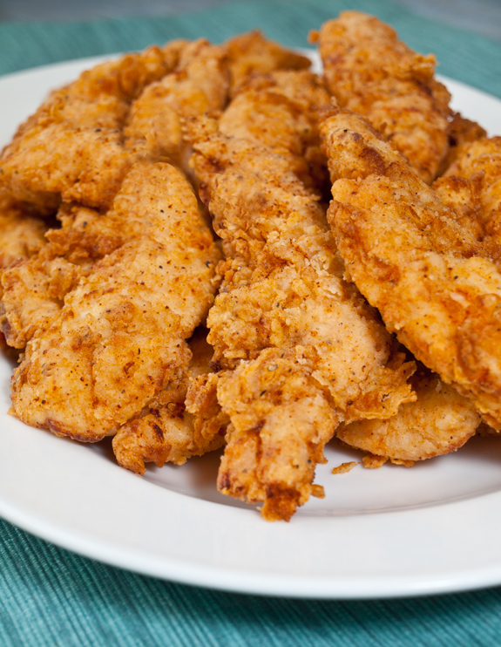

Description: This is the first part of a complete meal. I saw this first meal in a movie a long time ago filmed at Roscoe's Chicken and Waffles in Los Angeles. Too far to drive to go there. Joyce loves to cook Belgian waffles, and we both love chicken. So with the right ingredients, this is a match made in heaven. TESTED & PERFECTED RECIPE – These chicken tenders are marinated in seasoned buttermilk and pan-fried to crispy, crunchy perfection. They are tender and packed with so much flavor. You cannot eat just one, the aftertaste will make you go begging for more.
Field tested this on December 19, 2017, with my visiting Sister-In-Law (Linda) who enjoys coming to our home for Christmas vacation and of course eating meals with Joyce and myself. The neighbors say they can smell the food cooking from down the street. At least that's what my daughter (Christina) says when arriving unexpectedly but always around 5 PM because she knows that it is dinner time.
I love to cook, but afterward, I can't eat right away. I always fix myself a refreshing drink and wait for the sounds of approval by those consuming the results of my hard work. Linda, my sister-in-law likes typically to watch her diet and eat only a small portion of the meals. She took her first bite out of this chicken, and I heard her say, "Oh my God!" I asked what was wrong and she says I got to have another piece of this chicken. Well, she had four pieces and so did my lovely wife, Joyce. Joyce normally approves by saying, "Honey this is SOOO good!" She also had more than one serving and then adds, " I can't get skinny with you cooking like this.".
This chicken was even better the second day. I placed it in the oven at 225 degrees to warm the second day and came out perfect. For those that like cold chicken you won't be disappointed with each visit to the refrigerator for a night time snack.

Prep Time 10 Minutes (Chicken cooked the night before)
Cook Time: 10 Minutes
Total Time 20 Minutes
Servings 4
Ingredients
Buttermilk Marinade

1 (3 1/2) pound chicken, cut into 8 pieces
1 teaspoon black pepper
1 teaspoon salt
1 teaspoon smoked paprika
1/4 teaspoon dried rosemary
1/4 teaspoon ground thyme
1/4 teaspoon dried oregano
1/4 teaspoon dried sage
1/2 teaspoon white pepper
1/4 teaspoon cayenne pepper
2 cups buttermilk

Seasoned Flour:
2 cups flour
1 teaspoon salt
1/2 teaspoon paprika
1/2 teaspoon cayenne pepper
1/2 teaspoon garlic powder
1/2 teaspoon white pepper
1/2 teaspoon onion powder
2 1/2 quarts peanut oil for frying

Directions

Toss together chicken pieces, black pepper, salt, paprika, rosemary, thyme, oregano, sage, white pepper, and cayenne in a large bowl to coat.

- Stir in milk till chicken is coated. Refrigerate for six hours.

- Mix flour, salt, paprika, cayenne, garlic powder, white pepper, and onion powder in an exceedingly large shallow dish.

- Remove chicken from the milk and dredge each bit within the seasoned flour. Shake off any excess and transfer to a plate.

- Heat vegetable oil in your large cast iron pan to 350 degrees F (175 degrees C). Add all the chicken to the pan and cook for ten minutes.

- Flip chicken items and cook for another 10-15 minutes.

- Take away chicken from the oil and transfer to a cooling rack set over a towel lined baking sheet. Let sit for ten minutes before serving. Save some leftovers for chicken & waffles for the next morning.

Supreme Breakfast Combination

Ultimate Buttermilk Waffles
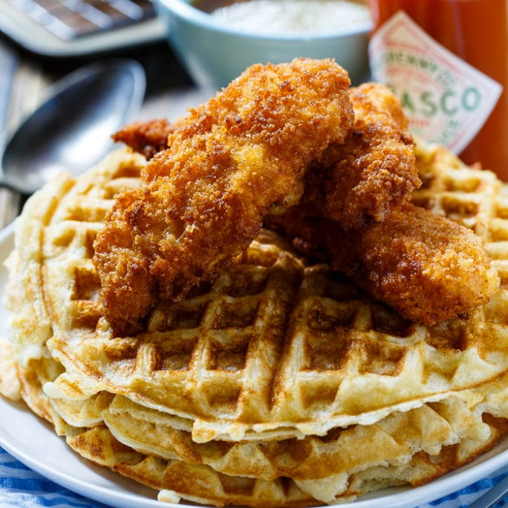

Description: Chicken and waffles is an American dish combining chicken with waffles. It is part of a variety of culinary traditions, including soul food and Pennsylvania Dutch cuisine, and is served in certain specialty restaurants in the United States.

Reference

Chicken And Waffles - Wikipedia. (n.d.). Retrieved from https://en.wikipedia.org/wiki/Chicken_and_waffles

Prep Time: 15 Minutes (if using leftover chicken)
Cook Time: 5 minutes per waffle
Total Time: 20 Minutes
Servings 6-8

Ingredients:

1 and 3/4 cups (210g) all-purpose flour
1 and 1/2 teaspoons baking powder
1 teaspoon baking soda
1/2 teaspoon salt
3 large eggs, separated
1/2 cup (115g) unsalted butter, melted and slightly cooled
1/3 cup (67g) granulated sugar
1 and 3/4 cups buttermilk*
1 teaspoon vanilla extract
butter + pure maple syrup for topping
¼ minced finely chopped Jalapeno

Directions:

- Heat up waffle maker on medium-high heat. Heat your oven to 200F degrees. Place a wire rack on a baking sheet; put aside.

- In a very giant bowl, mix the flour, leaven, sodium hydrogen carbonate (baking soda), and salt. Set aside. In another giant bowl, whisk the egg yolks, butter, sugar, buttermilk, and vanilla along till combined. Pour the wet ingredients into the dry ingredients and whisk gently till sleek. Don't overmix.

- In a very medium bowl, whisk the egg whites till stiff peaks kind. I generally use a hand-held or stand mixer fitted with a whisk attachment to whisk the egg whites. Employing a rubber spatula, gently fold the egg whites into the batter.

- Pour 1/3 cup of the batter into every well of the waffle maker (or less if your waffle maker is smaller) and shut the lid. Cook the waffles till golden brown and crisp, 5-6 minutes. Transfer the baked waffles to the wire rack and keep heat within the preheated kitchen appliance as you cook the remainder. Repeat to process to cook the remaining batter.

- Serve the waffles directly with warm butter and syrup, or your selection of toppings (fried chicken strawberries, etc).

- Build ahead tip: Waffles are best enjoyed same day. Refrigerate any extras for one or two days. Waffles are often frozen up to three months, then warm within the toaster.

Desert

Annapolis Creed: Goo Cake
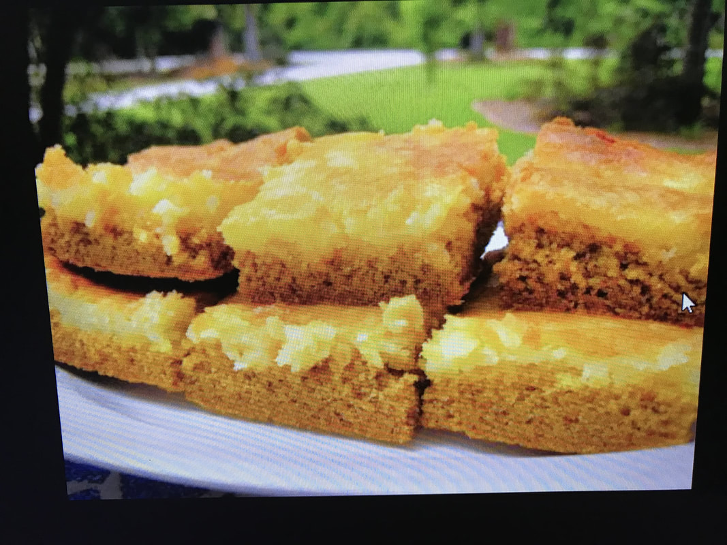

Description: Warning!
If you cook this, you will never stop cooking it for family and friends.
Original Recipe Name:
Ooey Gooey
History:
This cake is a legendary Depression-era mistake. The story goes that a baker in St. Louis accidentally mixed up the ingredient proportions for his cake, resulting in a gooey texture. Because it was the Depression, they couldn’t just throw it out, so they sold it, and it was an instant hit.
My Background with the Original Recipe
Although I was born in St. Louis, Missouri and lived there for my first eighteen years no one in my family had ever made this dessert. Believe me, after you have just one bite. The first words out of your mouth will be OMG! It like the old Lays Potato Chips commercial when I was growing up in the 90's. You can't just take one bite or one slice. You will want to steal it and eat the whole thing by yourself.
My first time eating a form of Ooey Gooey was upon my return from Operation Desert Shield/Desert Storm in June 1990. The West-bank Revival church in Terrytown, Louisiana gave me a welcome home party serving Kentucky Fried Chicken. Usually I would love to stuff my face with KFC but this time was different. Every desert has to look good, and this did, but after the first bite hit the taste buds, the look of it doesn't matter anymore.
During the Gulf War there were certain foods forbidden because of the religious traditions in Saudi Arabia and Kuwait and because of this there was no bacon or pork. The main meal was chicken. I was sick of chicken upon my return back to New Orleans. The church secretary (Susie I think) made this desert sprinkled with white powdered sugar. I don't usually eat a lot of deserts, but on that warm summer day, I had my first taste of the world's best dessert. I remember asking her what the name of the desert was and she said, "Ooey Gooey."
I won't ever forget that first bite and the name speaks for itself. I had one taste and knew I had to have this recipe. So I remember walking two miles to their home to get the recipe in 1990 because I had no car at the time. The method written on the back of a Christmas card got misplaced over the years, and so I never made it, but I did remember some of the ingredients because I saw her make it for another church function. I must have tried to duplicate the recipe dozens of times always failing. My experiments still lacked a missing ingredient or too much of one thing or another. In 2003 after finding the best wife ever (Joyce), I made it for a Christmas Eve party, and over the past fourteen years, I have finally perfected my version of that funny named dessert.
If you research it on the internet search for Ooey Gooey butter cake and the recipe that came close was the one from Paula Dean. But Paula's not the original, and my first memorable bite and taste had pecans in it. You will find multiple versions on the internet. Because I have family members, who are diabetic I had to modify the recipe to reduce the amount of sugar. The original was really sweet beyond the words because Susie would put four cups of sugar into cream mixture to top off the cake. So the name will have to change and below you will find one of the enduring family recipes from my next book (Annapolis Creed: Enduring Classic Recipes) done in collaboration with my wife Joyce as we record our family traditional meals from Pops and Nana Joyce.
Bon Appetit!

Ingredients

Cake
1 (15.25 oz.) package butter cake mix
1 egg
8 tablespoons melted butter
1 teaspoon vanilla
½ teaspoon kosher salt
¼ cup brown sugar
1 package pecan half pieces or pecan pieces

Goo
8 tablespoons melted butter
1 (8 oz.) package Philadelphia softened cream cheese (microwave for 45 seconds)
2 eggs
1 teaspoon vanilla
1 cup (16 oz.) powdered confectionary sugar
1 cup light brown sugar
1 teaspoon Wild Turkey or Jack Daniels Bourbon (Age & Flavor)

Christmas Holiday Topping (Optional)
¼ teaspoon nutmeg to cake mixture (optional for Christmas time)
¼ teaspoon cinnamon to cake mixture (optional for Christmas time)

Directions

Preheat oven to 300 °F.

- Apply butter flavored cooking spray to a 13 by 9-inch baking pan. Take 1 tbsp. Of flour to coat the bottom and sides of the pan, shake and discard the excess.

- Combine the cake mix, 1 eggs, 8 tablespoons butter and mix well with an electric mixer or by hand. Pat the mixture into the bottom of a lightly greased 13 by 9-inch baking pan.
- Add the pecans to the top of the cake mixture.

- Place cream cheese in microwave for 30-45 seconds to soften. In a large bowl, beat the cream cheese until smooth. Add the 2 eggs, vanilla extract, and 8 tablespoons butter and beat together.

- Next, add the powdered sugar, brown sugar, vanilla, (optional nutmeg & cinnamon), Wild Turkey Bourbon, and mix well. Spread over cake batter and bake for 40-50 minutes. Bake at 350 for 30-45 minutes or until topping is golden. Allow to cool somewhat to set topping (slides off when warm). Make sure not to overbake as the center should be a little gooey.

Enduring Classic Recipes save time and money
Tightening the purse strings suggests that obtaining inventive along with your weekly menu. The price of food is on associate upward flight. Therefore it's sensible to induce into the application of batch preparation enough for 2 or more additional meals.

Playing Iron cook with all the scraps and leftovers you’ve compiled over a couple of homemade dinners isn't everyone's best talent. Searching separately for every formula can usually leave you with some byproducts: half-used bunches of vegetables, carrot topnotch, fennel stalks, and shreds of leftover roast chicken.

Enduring classic recipes is about the importance of home dinners to enrich the lives of family members and to throw in a little spice of mathematics to taste and expand the minds of all.

Can you see the circles within this picture? Share this with your family. (Hint there are more than 4) See the correct answer at
For more information and to receive upcoming recipes, please subscribe to our blog at www.enduringclassicrecipes.com or join our Facebook group at www.facebook.com/enduringclassicrecipes

About the Authors

Dr. Smith is an educational leadership specialist in curriculum and instruction who began his teaching career 28 years after graduating from the United States Naval Academy with the distinguishing himself being selected as the first African American Color Company Commander in the history of the service academy. Jordan and Joyce are now great-grandparents, and Joyce is in retirement. They live with their fellow food taster “Tommie” in Southern California. Dr. Smith loves to teach, and cooking is his relaxation that he loves to share. See “Annapolis Creed”

Passing on the formula your Grandparents had conferred upon them for quite a long time is thrilling and at same excitement. Preparation for your family and not merely ingestion what’s served all the time also can encourage you to remain more extended reception, to relax and additional significantly

Food is one of the foremost compelling things within the world, primarily as a result of we want it and that we dread for a tasty and pleasant course that we will boast to our co-workers within the morning. Another issue regarding home-made meals is regarding the preparation sessions that you just and your female parent or dada will have. Passing on the formula your Grandparents had conferred upon them for quite an time is thrilling and at same excitement.

Cooking for your family and not merely ingestion what’s served all the time also can encourage you to remain more extended reception, to relax and additional significantly update yourself with the remainder of the family’s achievements or stories. A square meal welcome can ascertain the square measure of joy or mainly the props that anyone will use to create a far better and happier family. If you've got some to spare, why not share it together with your peers or colleagues following day? It'll for specific cause you to nearer and more well-off as a result of food created reception continually has this ability of building relationships and making a new peaceful life.

I hope you relish these home-made meals and are available up with a number of your own further.

If you'd wish to receive additional recipes sign up at www.enduringclassicrecipes.com or follow us on www.facebook.com/enduringlcassicrecipes and join the Facebook group.

Get weekly recipes sent to your email at www.annapoliscreed.com/cookbook-materials.html

